# **M5StickC Speakers, Microphone, and Buttons**

**Objectives** – Understand the mechanics of the buttons on the M5StickC, Use hats with the M5StickC, Combine functions to provide a useful application.

BoM = M5StickC Plus, USB to USBC charging/connecting cable, Desktop PC

This program changes the screen color based on one of two buttons being pressed and displays text.

<https://youtube.com/shorts/6pkmq-QJlP4?feature=share> = Button Test

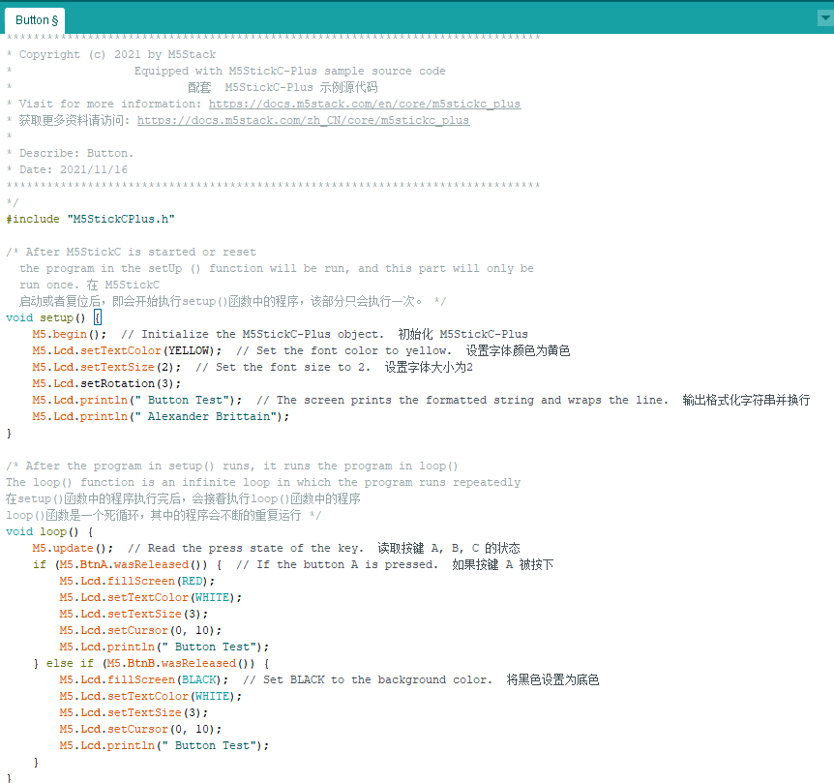

This program changes the color of the screen from black to red depending on which button is pressed.

<https://youtube.com/shorts/bG4yZfxB6KM?feature=share> = Screen Color Change

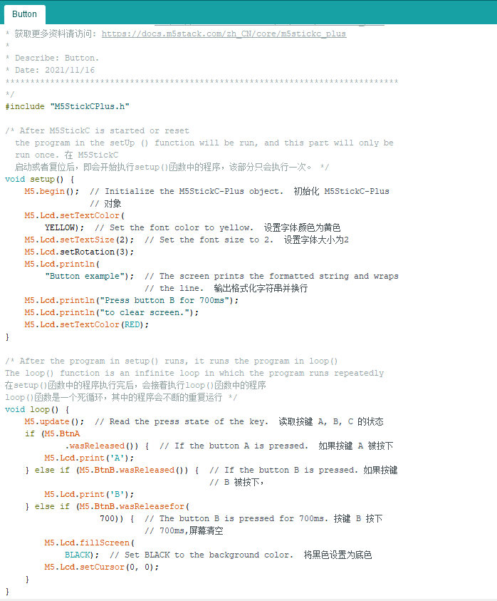

This program plays a sound from the speaker of the M5StickC Plus.

<https://youtube.com/shorts/4_5P_mW2Q50?feature=share> = Speaker Test

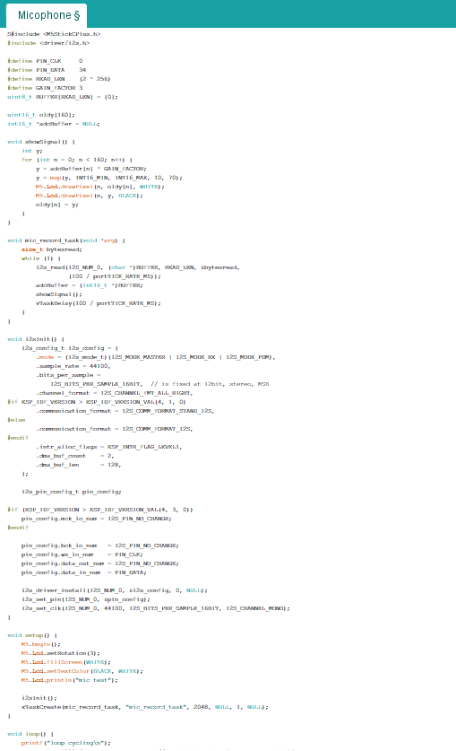

This program displays a microphone test detecting me speaking.

<https://youtube.com/shorts/BYGm5XeZEOU?feature=share> = Microphone Test

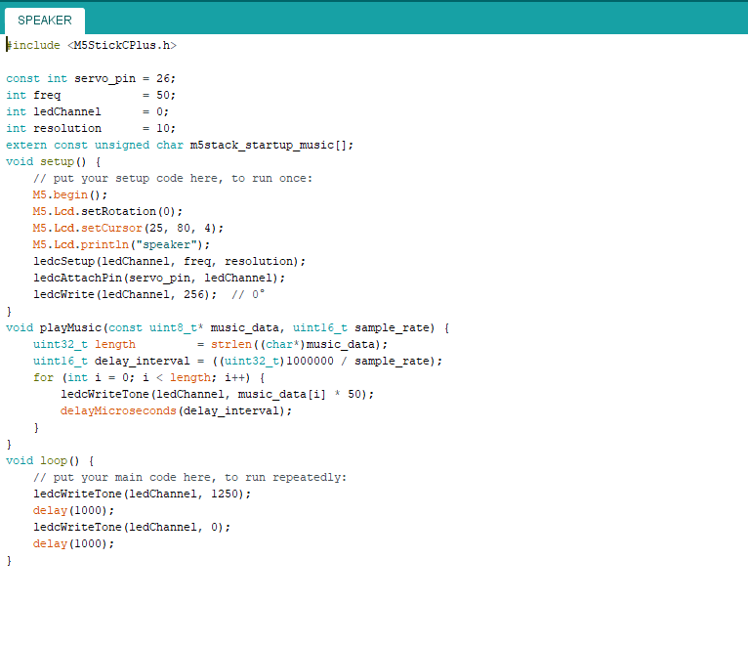

None of the lab tests that were done needed any sort of calculations.